eSOP Profile Guidance for Biostatistics

- PURPOSE
  - This document details the Enterprise System of Policies & Procedures (eSOP) profiles that correspond to the job categories within Biostatistics and references guidance with respect to removing profiles and self-registration of non-profile SOPs.
  - The eSOP Profile(s) for the user should match the job categories that align to their business unit or customer group within Biostatistics.
  - The reading list for Biostatistics documents each eSOP profile for the group and shows which SOPs appear on the reading list for users with those profiles. The Biostatistics Reading List is stored electronically and a current list can be obtained by running a report using the following link: SOP Reading List

- eSOP PROFILES FOR BIOSTATISTICS
Biostatistics has the following active Job Categories:
Job Category | Applicable Biostatistics Staff
All Biostatistics Positions | The default eSOP profile for Biostatisticians, Statistical Team Leads (STL) and Programming Team Leads (PTL) and their Line Managers.
Statistical Programmers | A restricted eSOP profile applicable to Statistical Programmers fulfilling non-lead roles. Lead Statistical Programmers are required to use All Biostatistics Positions.
Biostatistics Contractor | A restricted eSOP profile applicable to Biostatistics contractors and as a secondary profile for Line Managers of contractors.
Biostatistics Customer Solutions | A restricted eSOP profile used by some Functional Service Provider (FSP)-style job roles and their Line Managers (confirm if this selection applies to you with your Line Manager).
Global Bios | Only used by high-level management (such as Senior Directors who are not otherwise responsible for conducting any Biostatistics project tasks) and Data Sciences Staffing Solutions (DS3) staff.
FSP-Only
Phase I | A secondary eSOP profile, in addition to the “All Biostatistics Positions” profile, to be used by all Early Clinical Development (ECD) Biostatistics staff and their Line Managers.

- PRIMARY AND SECONDARY PROFILES
  - Select PRIMARY User Profile based on your Biostatistics role and customer group, if applicable.
  - Select SECONDARY User Profile(s) for any additional responsibilities or roles.

- INSTRUCTIONS
Instructions for loading eSOP Profiles:
 | 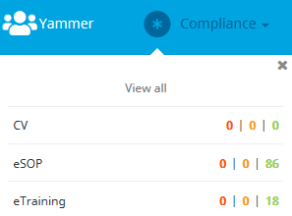 | Open the IQ homepage.  - Navigate to “Compliance” in the top right corner of the main bar on the IQ homepage:  - Select “eSOP” in the drop-down list  - Select “USER PROFILE” from the menu on the left
 | 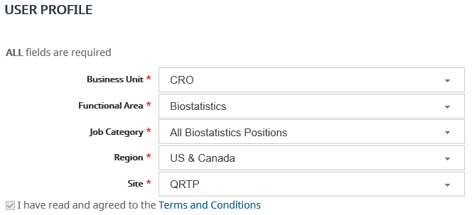  For loading a primary user profile: | Complete the fields as follows:  Business Unit = CRO  Functional Area = Biostatistics  Job Category = See table in 5.0 below  Region = [your region*]  Site = [your site*]  *Confirm selection with your Line Manager.
 | For loading a secondary user profile:  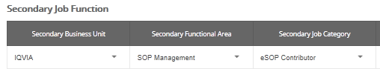 | Complete the following fields per Section 6.0  Secondary Business Unit  Secondary Functional Area  Secondary Job Category

- eSOP PROFILE PER JOB ROLE AND CUSTOMER GROUP
The following profiles apply per business/customer group:
Job Category | Applicable Bios Department | Bios Roles |  |  | Contractor
 |  | Biostatistician | Statistical Programmer | Bios Lead – STL and PTL
All Biostatistics Positions | Non-DP, DP¹, ECD - Bios | X |  | X
Statistical Programmers | Non-DP, DP¹, ECD - Bios |  | X
Biostatistics Contractor | Non-DP, DP¹, ECD - Bios |  |  |  | X^{b}
Biostatistics Customer Solutions | DP² | X | X | X
Global Bios / FSP-Only | DS3 | X | X | X
Phase 1 | ECD - Bios | Xª | Xª | Xª
See table abbreviations and notes on the next page.
Abbreviations:
Non-DP | Non-dedicated partnerships (Biostatistics & Statistical Programming)
DP¹ | Dedicated partnerships working on IQVIA systems and following IQVIA SOPs
DP² | Dedicated partnerships not working on IQVIA systems nor following IQVIA SOPs
DS3 | Data Sciences Staffing Solutions
ECD | Early Clinical Development Staff
Note:
The job categories Statistical Programmers, Biostatistics Customer Solutions, Global Bios/FSP-Only, and Biostatistics Contractor are all subsets of the All Biostatistics Positions. It is acceptable to replace any of these roles with the All Biostatistics Positions category.
ª Add as a secondary job function.
^{b} Line Managers are to load the “Biostatistics Contractor” profile, as a secondary profile, if any contractor staff report to them.

- OTHER NON-BIOSTATISTICS SECONDARY PROFILES
The following Non-Biostatistics profiles may be required by staff, please confirm the addition of any of these roles with your Line Manager:
Job Category | Applicable Biostatistics Staff | Field completion
eSOP Contributor | Biostatistics SOP task force, SOP approver and process owners | Secondary Business Unit = IQVIA  Secondary Functional Area = SOP Management  Secondary Job Category = eSOP Contributor
DM SAS Programmer | Applicable to some SDTM-only programmers within specific partnerships | Secondary Business Unit = CRO  Secondary Functional Area = Data Management  Secondary Job Category = SAS Programmer
Virtual Trials | Required for STLs working on virtual trials | Secondary Business Unit = CRO  Secondary Functional Area = Virtual Trials  Secondary Job Category = Biostatistics Lead
eTMF Contributors | Required for anyone contributing to any eTMF platform. | Secondary Business Unit = CRO  Secondary Functional Area = Trial Master File  Secondary Job Category = IQVIA eTMF (Wingspan)*  * The Wingspan platform is the most common and is provided above. If you are utilizing another eTMF platform, such as ELVIS DIA, ELVIS pre-DIA, Single-Service, Customer eTMF you will need to refer to CS_OD_TMF0012 for additional details about the eSOP profile to add.

- UPDATING YOUR USER PROFILE
Your eSOP User Profile should be reviewed at least twice annually with your manager to discuss necessary updates, or whenever your job functions, role or responsibilities change. See CS_WI_BS0240 (Biostatistics Training Management) for additional details for reviewing eSOP profiles. For details on updating a primary profile or removing a secondary profile refer to “Updating Your eSOP Profile” in QG_OD_SMT0084 (My eSOPs Quick Reference Guide).

- SELF-REGISTERING FOR AN SOP
Employees may be required to read and acknowledge individual non-profile based controlled documents with respect to specific non-Biostatistics tasks or local procedures. Add the documents as “Individually Registered SOPs”, when applicable. Individually Registered SOPs will trigger IQVIA Intranet alerts when that SOP is revised. Refer to “Registering Individual Documents in My eSOPs” in QG_OD_SMT0084 for instructions on self-registration.

Note: SOPs manually added to reading lists via the SEARCH function must be manually removed when they are superseded or made obsolete. For additional details on notification of New or Revised SOPs, refer to QG_OD_SMT0084.

- SUPPORTING DOCUMENTATION AND USEFUL REFERENCES
DOCUMENT NUMBER | TITLE
ESOP References
- QG_OP_SMT0008 | Introduction to the Enterprise System of Policies & Procedures-eSOP
- QG_OD_SMT0084 | My eSOPs Quick Reference Guide
- QG_OD_SMT0085 | Enterprise System of Policies and Procedures (eSOP) User Manual
- CS_OD_TMF0012 | QRG – TMF eSOP Job Categories
- CS_WI_BS0240 | Biostatistics Training Management
Other References
- Reading Lists | SOP Reading List

